KILBURN SQUARE NEWSLETTER
May 2019



Useful information of what’s happening on your estate including events.

Please note the Kilburn Square Clinic path way is currently closed due to health and safety issues. Once the Council have outlined their intentions for the Clinic this will be in consultation with the TMO.

G

Special Collection of Furniture and Items
Please note all tenants and leaseholders are responsible for arranging special collection of bulky furniture and items through Brent Council. The dumping of large household items on the estate by residents continues to be a problem, and the TMO are incurring the cost to remove and dispose of these items.
Please note the costs of any for refuse collection on the estate will have an impact on your service charges. Please note any items to be collected should only be left outside on the day that has been agreed for collection. No items must be left in the communal arears. Brent Council operates a bulk collection service for up to five items at a cost of £35.00. To arrange a special collection contact Brent Council on 020 8937 5050.
When you are given your reference number you need to provide this to the staff at Kilburn Square reception along with a list of items and your collection date. All bulk refuse can then be placed at the side of the compound gates for collection.

Get Involved and Have Your Say!
Kilburn Square Housing Co-op is a limited company registered with the Financial Services Authority as an Industrial and Provident Society (Registration number IP27573R). It was set up in 1994 as a Tenant Management Organisation governed in line with the Right to Manage Legislation. As a Tenant Management Organisation (TMO) we are in charge of cleaning, grounds maintenance gardening and repairs.

A voluntary elected board of residents meet each month to oversee governance, consult on funding and future plans for our estate. From crime prevention, building developments, to parking.

…Become a Member
All residents and leaseholders are welcome to join Kilburn Square Housing Co-operative membership. Membership is £1.00 each, if you are a co-op member you can attend General Meetings and Annual General Meetings. You have a vote and can stand on the board and have your say on issues that are important you.

For a one off fee of just £1.00



…. Become a Board Member

This takes a level of commitment and should not be viewed lightly. However, it is rewarding and will widen your experience. You will be inducted and receive training
to cover governance, finance, management, annual reports, business plans and computer skills, equal opportunities, and GDPR. If you are interested in becoming a board member contact the Chair James Lewis via the Kilburn Square Office.

Your TMO Board Members are:

James Murphy Lewis – Chair
Denise Prieto – Deputy Chair
Jennifer Welch – Secretary
Isabel Sanchez Cassidy – Treasurer
Nicola Chapman
Rehana Khawaja
Patricia Hogan
Margaret Von Stoll

Blocked Rubbish Chutes

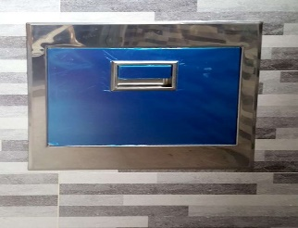

Our cleaning staff are continually having to unblock chutes caused by residents placing oversized items down the chutes like pizza, boxes, cardboard boxes etc. These items should be placed in the recycling bins.

MEETINGS AND EVENTS FOR 2019…………..

All Residents and Leaseholders are encouraged to attend future Board Meetings to have your say on how the TMO provide services to the estate.


Board Meetings  Tuesdays at 7.15pm | General and Annual General Meetings  Thursday at 7.30pm
14th May 2019 | 13th December cancelled
11th June 2019 | General Meeting 13th June 2019
9th July 2019
13th August 2019
10th September 2019 | Annual General Meeting 12th September 2019
8th October 2019
12th November 2019
10th December 2019 | General meeting and Christmas Party 12th December 2019
To access the new website you need to enter into your browser www.kshc.org.uk
This will give you access to all information and updated news on the TMO.

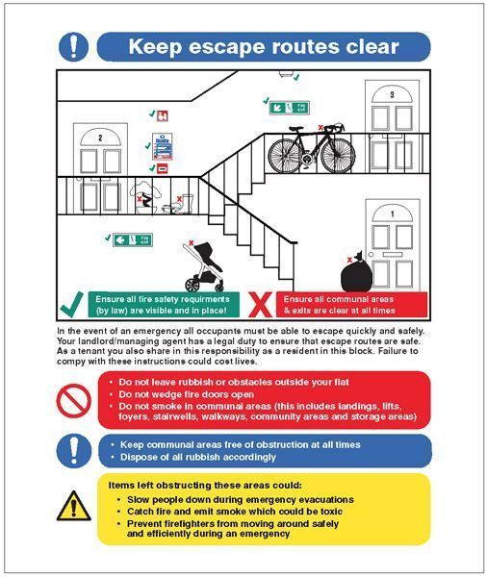

Website:www.kshc.org.uk

