KILBURN SQUARE NEWSLETTER
  - November 2016

Useful information of what’s happening on your estate including events.
G




Welcome to Kilburn Square newsletter for November 2016.
Kilburn Square currently has 9 Committee Members; please see below the names of our current Committee Members.

TITLE | NAME
Chair | Margaret Stoll
Deputy Chair | Vacant
Secretary | Jennifer Welch
Treasurer | Mahmood Hassan
Committee Member | Pauline Fell
Committee Member | Zaler Montana
Committee Member | Martin Page
Committee Member | Antonio Messina
Committee Member | Patricia Hogan

Kilburn Square Tower Block
Please note we have received a number of complaints about food and glass jars been thrown out of the windows in the Tower block. Please note this is a breach of your Tenancy Agreement/Lease and a serious health and safety issue. If the perpetrator is caught, it could result in you losing your tenancy or lease being revoked by the Council.
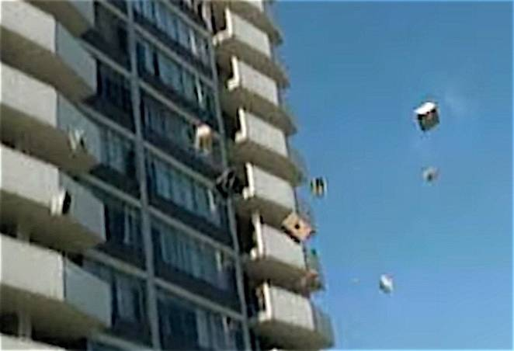

Modular Management Agreement (MMA)
It has been in discussion for some time that our current management agreement dated 1994 needs to be reviewed. There are lots of changes within Brent Council and cuts to revenue and part of these changes means Kilburn Square Housing Co-operative has to focus on renewing the management agreement. The MMA has now been reviewed and returned to Brent Council , an update of the MMA will be given to all residents when Brent have returned the document back to us.

This may also mean KSHC having to consider doing some fundraising in order to balance the books and to fund events held at Kilburn Square.

Resident Participation
Come out in your numbers on a Friday in the committee room where there is fun and laughter and BINGO. It’s a way of meeting others on the estate and having fun. All are welcome.
Co-op Membership

All leaseholders and tenants are welcome to join Kilburn Square Housing Co-operative membership. Membership is £1.00 each. If you are a Co-op member you can attend General Meetings and Annual General Meetings and you can voice your opinions on matters. Have your say on the running of the estate and receive a discount price for events by Kilburn Square. Please note leaseholders sub-tenants cannot become a member.
Downsizing

Brent Partnership Housing held an event on 19th October 2016 for all tenants living 2 & 3 bedroom properties that are under occupying. Many of residents are living in properties that are too big for them. This means that energy and maintenance costs are probably very high. If this is you, why not consider somewhere smaller?
DID YOU KNOW?
Brent currently pays £2000 per bedroom that that you downsize by, up to a maximum of £6,000. Come along to the meeting to register your interest.
Halloween Party

Kilburn Square held their annual Halloween Party on Saturday 29th October 2016.

Kilburn Square Tower block Window Overhaul
Eight flats within Kilburn Square Tower block have had their windows overhauled as they were suffering from water penetration. The works were carried out on Tuesday 11th October 2016.
Capital Windows abseiling team CAN UK Ltd abseiled down Kilburn Square tower block in order to carry out some external works to a number of windows. The operatives were on site from 8.00am-5.00pm. A number of vents need to be replaced but these have been ordered.

Macmillan Cancer Support
Kilburn Square Housing Co-op held a coffee morning on Saturday 1st 0ctober 2016. To raise funds for Macmillan cancer support, so people facing cancer can have the support they need to feel more in control of their life, from the moment they’re diagnosed, through treatment and afterwards. An array of baked goods and refreshments were made available on the day.
Kilburn Square raised £160.00 on the day thank you so much for baking a difference.

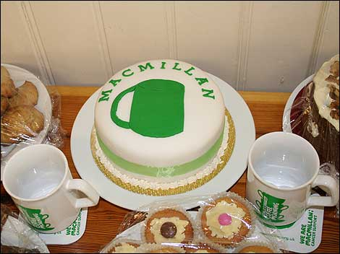


Major Works on the Kilburn Estate
Major works have now started on the four low rise blocks Barrett, Rathbone, Sandby and Varley House, and scaffolding is been erected. The work will include new roofs, new double glazing windows, new balcony doors, masonry work, and some decorations.

The Resident Liaison for Wates is Michael Bell contact number 0742 764 9894.
Any problems or concerns you may have in regards to the works he can be contacted on the number between the hours of 9am-5.00pm. He is based in the blue porta-cabins in the compound on the estate.
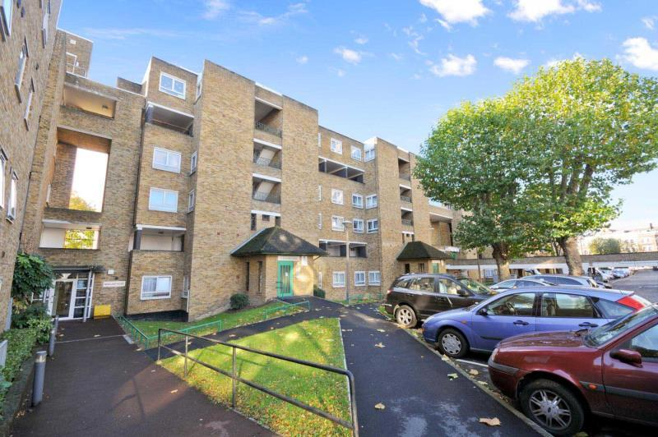
New gates to the estate!!
The works have commenced on the gates around the estate and is now completed.

Behaviour of Children on the estate

All parents must ensure that they take full responsibility for the behavior of their children and their friends. This includes when your child is playing on the estate. Parents and guardians must ensure that they know the whereabouts of their children and you should monitor your children when they are out to ensure they are safe.

Failing to ensure that members of household or visitors do not cause a nuisance is a breach of the terms and conditions of your agreement with Brent Council. Persistent anti- social behaviour may lead to agreements being terminated and the loss of your home.

Health and Safety

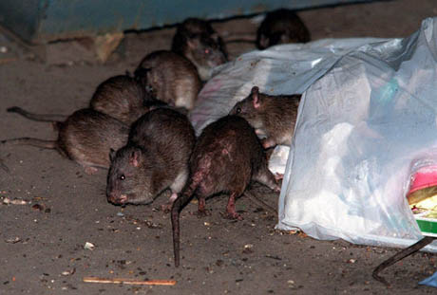
Rodents on the rise!! We do not want to encourage rodents on our estate please do not leave rubbish outside your front doors or dump bulky items in the yard, this has led to a rise in rodents and we have had to increase and change the bait we use around the estate to ensure we are managing the increase. Help us to have a clean estate where were proud to live. Be aware for health and safety reasons rubbish or items must not be left outside your front doors.

Contact Information
We need to ensure that we have your current contact numbers on our database, particularly mobile numbers. If you have recently changed your contact number, please inform the office.

Housing Management Staff structure 2016

Housing Services/Estate Manager Jennifer Williams

Housing Officer Linda Ponder

Finance Officer Yasmita Kotecha

Maintenance Officer Rudy Kelly

Front Desk/Security Co-ordinator Karis Pink

Caretakers William Borrill
Kathy Proudfoot Jones Ivory

MEETINGS AND EVENTS FOR 2016…………..

All Residents and Leaseholders are encouraged to attend future Board Meetings to have your say on how the TMO provide services to the estate.



Board Meetings are held every 1st Tuesday of the Month
6th December 2016
10th January 2017
7th February 2017
7th March 2017
4th April 2017
9Th May 2017
6th June 2017
4th July 2017
8th August 2017
5th September 2017
4th October 2016
1st November 2016
6th December 2016
10th January 2017
7th February 2017
7th March 2017
4th April 2017
9Th May 2017
6th June 2017
4th July 2017
8th August 2017
5th September 2017

General & AGM meetings Thursdays
8th December- General Meeting & Christmas Party
16th March 2017- General Meeting
15th June 2017- General Meeting
14th September 2017 AGM

