KILBURN SQUARE NEWSLETTER
  - August 2017

Useful information of what’s happening on your estate including events.
G




Welcome to Kilburn Square newsletter for August 2017.
Kilburn Square currently has 7 Committee Members; please see below the names of our current Committee Members.
TITLE | NAME
Chair | Margaret Stoll
Deputy Chair | Vacant
Secretary | Jennifer Welch
Treasurer | Antonio Messina
Committee Member | Pauline Fell
Committee Member | Zaler Montana
Committee Member | Martin Page
Committee Member | Vacant
Committee Member | Patricia Hogan
Office Opening Hours- 9.00am- 5.00pm

Special Collection of Furniture and Items
Please note all tenants and leaseholders are responsible for arranging special collection of bulky furniture and items through Brent Council.
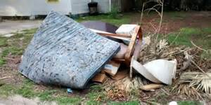
Kilburn Square Housing have incurred costs for refuse collection on the estate. This will have an impact on your service charges in the future if this continues to happen. To arrange a special collection contact Brent Council on 020 8937 5050.
When you are given your reference number you need to provide this to the staff at Kilburn Square reception along with a list of items and your collection date. All bulk refuse can then be placed at the side of the compound gates for collection.

Fire Safety



Following the recent fire at Grenfell Tower, naturally a number of residents will be concerned.
I can confirm that BHP have undertaken Fire Risk Assessment on the Tower block and we are 100% compliant.
Fire safety is the number one priority and BHP will continually review fire risk assessments, servicing and maintenance programmes to ensure residents are safe.
In order to ensure we maintain our safety, there are a number of things which you as residents can do to keep safe.

- Make sure you have a working smoke alarm in your home
- Keep balconies free from clutter
- Please don’t leave rubbish or bikes in communal areas or obstruct escape routes
- Make sure you know where your nearest fire exit is
- If you are a smoker please do not smoke in common arears of the block, including the lift.
- Always fully extinguish cigarettes smoked in your home and dispose of them carefully and safely.

Housing Benefit
You could get Housing Benefit to help you pay your rent if you’re on a low income.
Housing Benefit can pay for part or all of your rent. How much you get depends on your income and circumstances.
You can apply for Housing Benefit whether you’re unemployed or working.
You may also be able to get help with your rent if your benefits stop.
Housing Benefit can’t be paid for heating, hot water, energy or food

What you'll get
You may get help with all or part of your rent. There’s no set amount of Housing Benefit and what you get will depend on whether you rent privately or from a council.

Council and social housing rent
How much you get depends on:
- your ‘eligible’ rent
- if you have a spare room
- your household income - including benefits, pensions and savings (over £6,000)
- your circumstances, for example the age of people in the house or if someone has a disability

Eligible rent
Eligible rent means the reasonable rent for a suitable property in your area. It includes service charges (such as for lift maintenance or a communal laundry) but not things like heating.

Spare bedrooms
Your Housing Benefit could be reduced if you live in council or social housing and have a spare bedroom. The reduction is:
- 14% of the ‘eligible rent’ for 1 spare bedroom
- 25% of the ‘eligible rent’ for 2 or more spare bedrooms
Example reduced housing benefit
Your eligible rent is £100 per week. Housing Benefit pays £50 and you pay £50. You have 1 spare bedroom so the reduction is 14%. This means your Housing Benefit will be reduced by £14 per week.

Sharing bedrooms
The following are expected to share:
- an adult couple
- 2 children under 16 of the same sex
- 2 children under 10 (regardless of sex)
The following can have their own bedroom:
- a single adult (16 or over)
- a child that would normally share but shared bedrooms are already taken, for example you have 3 children and 2 already share
- children who can’t share because of a disability or medical condition
- a non-resident overnight carer for you or your partner (but only if they must stay overnight)
One spare bedroom is allowed for:
- an approved foster carer who is between placements but only for up to 52 weeks from the end of the last placement
- a newly approved foster carer for up to 52 weeks from the date of approval if no child is placed with them during that time
Rooms used by students and members of the armed or reserve forces will not be counted as ‘spare’ if they’re away and intend to return home.
Please note any correspondence that you receive from Housing Benefit/ DWP. We will need a copy in the office in order to provide assistance with rent queries.
Help with your Rent
Paying your rent and any charges should be your top priority, and regardless of how you pay, you are responsible for ensuring that these are paid in full, and on time. Non-payment of rent, service charges or any other charge could lead to you losing your home.
Tenants are reminded that rent is payable weekly in advance, or monthly in advance.

Housing staff will provide advice and guidance for tenants who have difficulty in paying rent. Whilst ‘Recovery of Possession’ (Eviction) of property is a last resort, Kilburn Square Housing Co-operative needs to protect its income and will take action against tenants who fail to pay their rent.
However, we recognise that there are many reasons why a tenant may have rent arrears.

If you have rent arrears and we have written to you, you must contact the Co-op office.

We will arrange a mutual appointment for you to see the Housing Officer or the Manager in confidence.

We will help you to get advice and support so that you can pay your rent.
And arrange a repayment plan to reduce and clear the arrears.

Housing Benefit
If you are on a low income or unemployed you may be entitled to claim Housing Benefit Rebate.
We can help you to do this.
Please remember your home is at risk if you do not pay your rent
Trees
Following a survey of trees on Kilburn Square Estate undertaken by a professional arboriculturalist. A number of tress required urgent works under health and safety. The majority of the work has started the contractors will be back on site as from the 14th of August 2017 to complete all the works identified in the report.
.
Gas Safety Checks
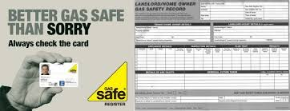
Landlords are legally obliged (in accordance with Gas Safety Regulations 1998) to obtain a gas safety certificate (CP12) every twelve months. Therefore it is imperative that tenants co-operate with the Council in order for the (CP12) to be completed.
The contractor will be entitled to charge the Council for visits following evidence that they have arranged and made 3 unsuccessful visits. These charges will be recharged to the tenant.

Forced Entry
As a final mechanism to ensure the Council compliance with its statutory obligations, it will force entry to carry out a service. Every effort will be made to avoid this, through written correspondence and other appropriate methods of communication.
Please note if the Council have to apply to the courts for a warrant for forced entries. The tenant will be recharged £300.14 minimum, this could increase dependent on what locks are changed. The amount will be added to your rent account for recovery.
Security on the estate

Residents are reminded that they need to close the doors behind them when exiting their block.
Resident Participation
Come out in your numbers on a Friday in the committee room where there is fun and laughter and BINGO. It’s a way of meeting others on the estate and having fun. All are welcome.

Co-op Membership

All leaseholders and tenants are welcome to join Kilburn Square Housing Co-operative membership. Membership is £1.00 each. If you are a Co-op member you can attend General Meetings and Annual General Meetings and you can voice your opinions on matters. Have your say on the running of the estate and receive a discount price for events by Kilburn Square. Please note leaseholders sub-tenants cannot become a member.

Kilburn Square 5 Year Ballot

Under the Management Agreement between your TMO and Brent council, we must hold a confidential ballot of all tenants and leaseholders every five years to ask if you are happy with the services the TMO provides and whether you want your TMO to continue managing the estate for another 5 years. The ballot will be facilitated by Open Communities - an independent ballot company.
The ballot will begin on the 1st September 2017 and run for 21 days. In the final week of the ballot period staff from Open Communities will be knocking on doors to encourage you to use your vote. These staff will be wearing ID badges. You will receive your ballot paper by the 1st of September along with a cover letter explaining how you can cast your vote. We look forward to your continued support in the ballot.

Contact Information

We need to ensure that we have your current contact numbers on our database, particularly mobile numbers. If you have recently changed your contact number, please inform the office. We also need to be informed of your next of kin in case of emergencies.


Out of Hours Repairs
An emergency repairs service is available outside normal office hours.
To report a repair out of hours contact 0208 937 1234

Housing Management Staff structure 2017

Housing Services/Estate Manager Jennifer Williams

Housing Officer Linda Ponder

Finance Officer Yasmita Kotecha

Maintenance Officer Rudy Kelly

Front Desk/Security Co-ordinator Karis Pink

Caretakers William Borrill
Kathy Proudfoot Jones Ivory

MEETINGS AND EVENTS FOR 2017…………..

All Residents and Leaseholders are encouraged to attend future Board Meetings to have your say on how the TMO provide services to the estate.


Board Meetings are held every Month
15th August 2017
12th September 2017
General & AGM meetings Thursdays
14th September 2017 AGM
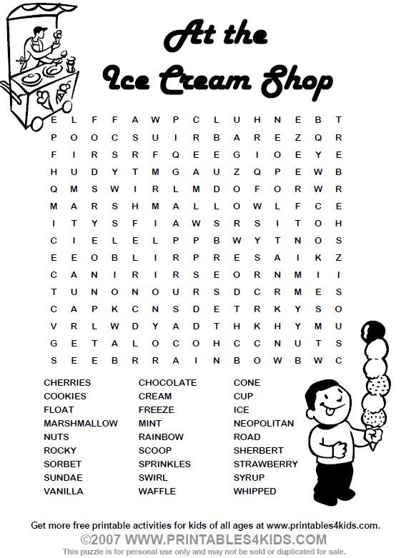

YOUR VOTE IS IMPORTANT



