KILBURN SQUARE NEWSLETTER
  - November 2017

Useful information of what’s happening on your estate including events.
G
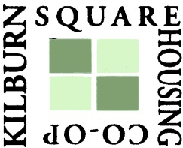



Welcome to Kilburn Square newsletter for November 2017.
Kilburn Square Board Members
TITLE | NAME
Chair | Margaret Stoll
Deputy Chair | Patricia Hogan
Secretary  Deputy Secretary | Jennifer Welch  Pauline Fell
Treasurer | Antonio Messina
Committee Member | Charlotte Fonceca
Committee Member | Maxwell Antwi
Office Opening Hours- 9.00am- 5.00pm

Special Collection of Furniture and Items
Please note all tenants and leaseholders are responsible for arranging special collection of bulky furniture and items through Brent Council.
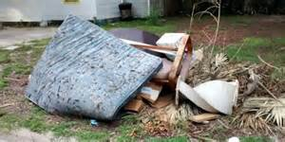
Kilburn Square Housing have incurred costs for refuse collection on the estate. This will have an impact on your service charges in the future if this continues to happen. To arrange a special collection contact Brent Council on 020 8937 5050.
When you are given your reference number you need to provide this to the staff at Kilburn Square reception along with a list of items and your collection date. All bulk refuse can then be placed at the side of the compound gates for collection.

Fire Safety



Following the recent fire at Grenfell Tower, naturally a number of residents will be concerned.
I can confirm that BHP have undertaken Fire Risk Assessment on the Tower block and we are 100% compliant.
Fire safety is the number one priority and BHP will continually review fire risk assessments, servicing and maintenance programmes to ensure residents are safe.
In order to ensure we maintain our safety, there are a number of things which you as residents can do to keep safe.

- Make sure you have a working smoke alarm in your home
- Keep balconies free from clutter
- Please don’t leave rubbish or bikes in communal areas or obstruct escape routes
- Make sure you know where your nearest fire exit is
- If you are a smoker please do not smoke in common arears of the block, including the lift.
- Always fully extinguish cigarettes smoked in your home and dispose of them carefully and safely.

Right To Buy
If you are a secure tenant and you have been a council or social housing tenant for three years or more, you may have the Right to Buy your council home. The three years can be built up over time using a number of tenancies and with gaps in between. If you have a Right to Buy application in progress only emergency repairs will be undertaken within your property.

Misrepresentation
The attached notice was placed in the Kilburn Square tower block lift, giving the impression, it was sent by the Estate Manager. Producing false notices on the KSHC letterhead without permission is a criminal offence.
All residents are reminded that the Police can investigate and prosecute if there has been an offence committed. Please note this is considered fraud by false representation under the Fraud Act 2006.
Please note both KSHC and Brent Council will take legal action should this occur in the future.

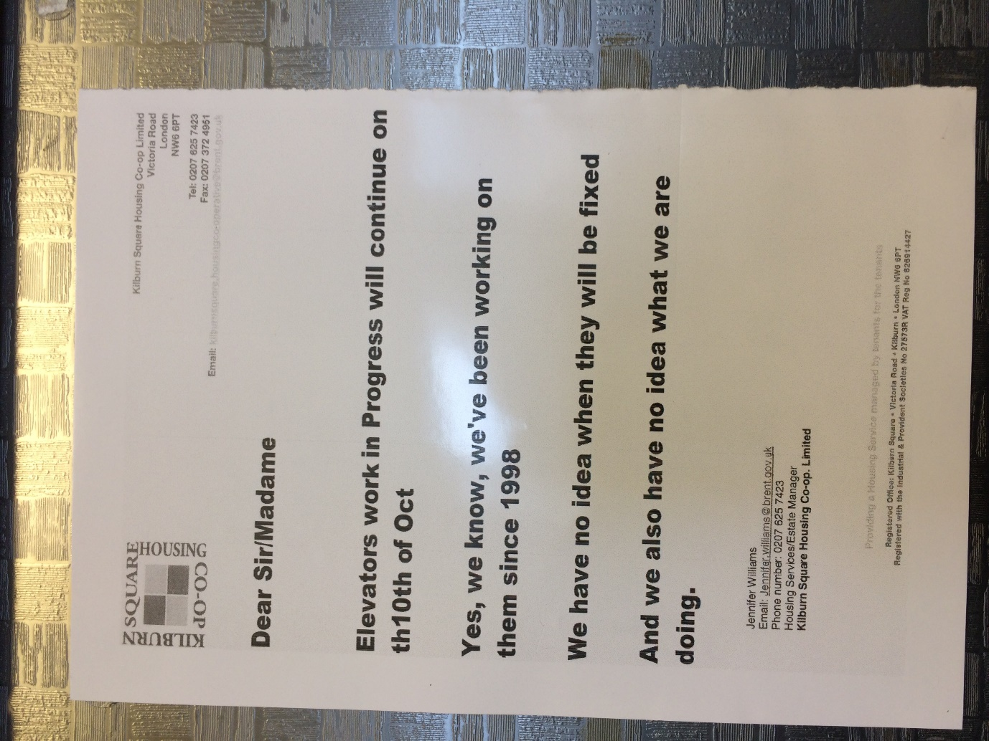

Brent Council Repairs Responsibilities

- The external structures of buildings, including brickwork, pointing, lintels, the external walls and their openings and all loadbearing, party and structural walls, but not minor repairs;

- The roof structure and roof coverings, but not minor repairs to roof coverings;

- The surface water and foul sewers, including gulley’s, access chambers and their coverings after the first chamber;

- The water mains from the Water Board’s supply pipe or stopcock to the mains stopcock in or serving each dwelling;

- The gas mains from the Gas Board’s main supply pipe or stopcock to the mains stopcock in or serving each dwelling;

- Lifts, including motors, hoists, cables, doors, shafts and any associated plant or machinery;

- Floors, including joists and floorboards;

- The protection and removal of asbestos materials;

- Firefighting or protection systems;

- Pest control and disinfestation;

- District Heating System.

Residents Responsibility
- Please note if you are intending to have any private works, carried out within your property. You are responsible for ensuring that you purchase visitor permits from Wing Parking. Contractors will not be able to park on the estate without a permit.
- Wing Parking contact details 01582 434500
Help with your Rent
Paying your rent and any charges should be your top priority, and regardless of how you pay, you are responsible for ensuring that these are paid in full, and on time. Non-payment of rent, service charges or any other charge could lead to you losing your home.
Tenants are reminded that rent is payable weekly in advance, or monthly in advance.

Housing staff will provide advice and guidance for tenants who have difficulty in paying rent. Whilst ‘Recovery of Possession’ (Eviction) of property is a last resort, Kilburn Square Housing Co-operative needs to protect its income and will take action against tenants who fail to pay their rent.
However, we recognise that there are many reasons why a tenant may have rent arrears.

If you have rent arrears and we have written to you, you must contact the Co-op office.

We will arrange a mutual appointment for you to see the Housing Officer or the Manager in confidence.

We will help you to get advice and support so that you can pay your rent.
And arrange a repayment plan to reduce and clear the arrears.

Housing Benefit
If you are on a low income or unemployed you may be entitled to claim Housing Benefit Rebate.
We can help you to do this.
Please remember your home is at risk if you do not pay your rent

Gas Safety Checks
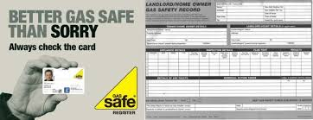
Landlords are legally obliged (in accordance with Gas Safety Regulations 1998) to obtain a gas safety certificate (CP12) every twelve months. Therefore it is imperative that tenants co-operate with the Council in order for the (CP12) to be completed.
The contractor will be entitled to charge the Council for visits following evidence that they have arranged and made 3 unsuccessful visits. These charges will be recharged to the tenant.

Forced Entry
As a final mechanism to ensure the Council compliance with its statutory obligations, it will force entry to carry out a service. Every effort will be made to avoid this, through written correspondence and other appropriate methods of communication.
Please note if the Council have to apply to the courts for a warrant for forced entries. The tenant will be recharged £300.14 minimum, this could increase dependent on what locks are changed. The amount will be added to your rent account for recovery.
Security on the estate

Residents are reminded that they need to close the doors behind them when exiting their block.
Resident Participation
Come out in your numbers on a Friday in the committee room where there is fun and laughter and BINGO. It’s a way of meeting others on the estate and having fun. All are welcome.

Co-op Membership

All leaseholders and tenants are welcome to join Kilburn Square Housing Co-operative membership. Membership is £1.00 each. If you are a Co-op member you can attend General Meetings and Annual General Meetings and you can voice your opinions on matters. Have your say on the running of the estate and receive a discount price for events by Kilburn Square. Please note leaseholders sub-tenants cannot become a member.
Permission to keep a pet
All residents are reminded you that you must seek written permission to keep a pet as detailed in your tenancy conditions.
Failure to seek consent may result in you having to re-home your pet immediately should your pet
Cause a nuisance or annoy other residents. You are responsible for your pet at all times, you must ensure that your dog is kept on a lead when on the estate and that you clean up any mess made by your dog.

Please note from April 2016 it now law that all dogs are microchipped and should wear a collar with a tag showing its’ owner’s name and address when out in public.

Brent Housing Partnership has produced a booklet on Animal Welfare Guidance if you have access to the intranet please go to the link below.

https://www.brent.gov.uk/media/9594812/Animal_Welfare_Guidance_Booklet.pdf

If you do not have access to the internet copies can be obtained from the Kilburn Square Office.

We are required to keep a register of all pets on the estate therefore please find enclosed a permission form to keep a pet which needs to be completed and returned to the office.

Before you buy a pet you need to obtain permission from Kilburn Square In advance.
Residents will not be given permission to keep a pet if it is considered by law to be dangerous or illegal in the United Kingdom.



Contact Information

We need to ensure that we have your current contact numbers on our database, particularly mobile numbers. If you have recently changed your contact number, please inform the office. We also need to be informed of your next of kin in case of emergencies.


Out of Hours Repairs
An emergency repairs service is available outside normal office hours.
To report a repair out of hours contact 0208 937 1234

ANTI-SOCIAL BEHAVIOUR

KSHC is committed to tackling anti-social behaviour as we know that it has a devastating impact on the lives of our tenants and leaseholders. Anti-social behaviour covers the range of behaviours from low-level nuisance to serious harassment, which can damage the quality of life and interfere with the ability of people to use and enjoy their home and/or community.

KSHC will not tolerate nuisance or anti-social behaviour directed towards tenants, leaseholders their visitors or any other engaged in lawful activity in the locality of our homes, including our colleagues, contractors and others acting on our behalf. This policy sets out:

- Our commitment to tackling anti-social behaviour;
- Our overall approach in relation to anti-social behaviour;
- The methods we will use to tackle anti-social behaviour.
Our aim is to achieve a balance between:
- Prevention
- Enforcement
- Support
We will use a range of ways to resolve anti-social behaviour:
- Early intervention and prevention to resolve the problem as quickly as is possible and consider mediation, if appropriate, early in the process;
- Use the full range of non-legal and legal tools available
- Partnership working where appropriate;
DEFINITION OF ANTI-SOCIAL BEHAVIOUR
The Crime and Disorder Act 1998 outlines anti-social behaviour in terms of its impact or likely impact on victims, as well as the actions of the perpetrators, specifically where a person is found to have:
“Acted in an anti-social manner, that is to say, in a manner that caused or was likely to cause harassment, alarm or distress to one or more persons not of the same household”.

Some examples of anti-social behaviour are:
- Rowdy behaviour including verbal abuse, insults, bullying shouting, swearing
- Noise
- Pets and animal nuisance
- Graffiti
- Drugs related
- Alcohol related
- Loitering on the estate
This is not an exhaustive list of behaviours that fall within the definition of anti- social behaviour
YOUR RESPONSIBILITY
Our Tenancy agreements and leases have clauses regarding anti-social behaviour and clearly sets out what is expected of our tenants and leaseholders. We expect our tenants and leaseholders to comply with the terms and conditions and to:
- Ensure that they their family and visitors, act in a considerate and reasonable way to others living in the community.



IF YOUR AFFECTED BY ANTI-SOCIAL BEHAVIOUR CAL 101

Gas Replacement Pipe Varley House

The contractors replacing the gas pipe on Varley House will be erecting scaffolding on Monday 30th October 2017.

Housing Management Staff structure 2017

Housing Services/Estate Manager Jennifer Williams

Housing Officer Linda Ponder

Finance Officer Yasmita Kotecha

Maintenance Officer Rudy Kelly

Front Desk/Security Co-ordinator Karis Pink

Caretakers William Borrill
Kathy Proudfoot Jones Ivory

MEETINGS AND EVENTS FOR 2017…………..

All Residents and Leaseholders are encouraged to attend future Board Meetings to have your say on how the TMO provide services to the estate.


Board Meetings are held every Month
14th November 2017
12th December 2017
14th December 2017 General Meeting and Christmas Party

