KILBURN SQUARE NEWSLETTER
  - April 2017

Useful information of what’s happening on your estate including events.
G




Welcome to Kilburn Square newsletter for April 2017.
Kilburn Square currently has 7 Committee Members; please see below the names of our current Committee Members.
TITLE | NAME
Chair | Margaret Stoll
Deputy Chair | Vacant
Secretary | Jennifer Welch
Treasurer | Antonio Messina
Committee Member | Pauline Fell
Committee Member | Zaler Montana
Committee Member | Martin Page
Committee Member | Vacant
Committee Member | Patricia Hogan

Kilburn Square Tower Block
Please note we have received a number of complaints about food and glass jars been thrown out of the windows in the Tower block. Please note this is a breach of your Tenancy Agreement/Lease and a serious health and safety issue. If the perpetrator is caught, it could result in you losing your tenancy or lease being revoked by the Council.
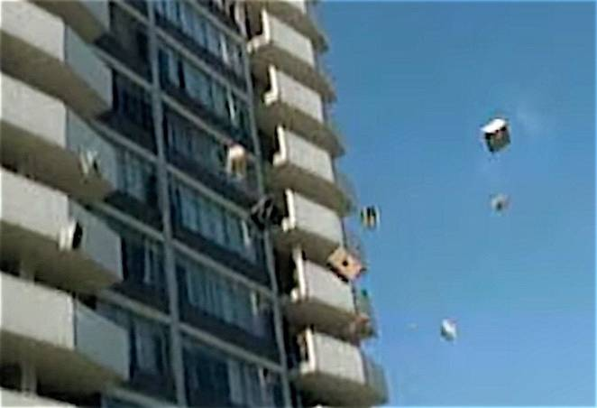

Modular Management Agreement (MMA)
It has been in discussion for some time that our current management agreement dated 1994 needs to be reviewed. There are lots of changes within Brent Council and cuts to revenue and part of these changes means Kilburn Square Housing Co-operative has to focus on renewing the management agreement. The MMA has now been reviewed and returned to Brent Council, an update of the MMA will be given to all residents when Brent have returned the document back to us.

This may also mean KSHC having to consider doing some fundraising in order to balance the books and to fund events held at Kilburn Square.

Gas Safety Checks
Landlords are legally obliged (in accordance with Gas Safety Regulations 1998) to get a gas safety certificate (CP12) every twelve months. Therefore it is imperative that tenants co-operate with the Council in order for the (CP12) to be completed.
The contractor will be entitled to charge the Council for visits following evidence that they have arranged and made 3 unsuccessful visits. These charges will be recharged to the tenant.

Forced Entry
As a final mechanism to ensure the Council compliance with its statutory obligations, it will force entry to carry out a service. Every effort will be made to avoid this, through written correspondence and other appropriate methods of communication.
Please note if the Council have to apply to the courts for a warrant for forced entries. The tenant will be recharged £300.14 minimum, this could increase dependent on what locks are changed. The amount will be added to your rent account for recovery.
Security on the estate

Residents are reminded that they need to close the doors behind them when exiting their block.
Resident Participation
Come out in your numbers on a Friday in the committee room where there is fun and laughter and BINGO. It’s a way of meeting others on the estate and having fun. All are welcome.

Co-op Membership

All leaseholders and tenants are welcome to join Kilburn Square Housing Co-operative membership. Membership is £1.00 each. If you are a Co-op member you can attend General Meetings and Annual General Meetings and you can voice your opinions on matters. Have your say on the running of the estate and receive a discount price for events by Kilburn Square. Please note leaseholders sub-tenants cannot become a member.
Carpark Gates Residents are reminded that they need to use their fobs when vacating the estate in a vehicle. Tailgating is the act of driving too close to the vehicle in front, such that the distance between the two vehicles does not guarantee that the gates will remain open.
“Shattif” Bidet shower Spray
Residents are reminded that they are not allowed to install bidet shower sprays in toilets within their flats.
Contact Information

We need to ensure that we have your current contact numbers on our database, particularly mobile numbers. If you have recently changed your contact number, please inform the office. We also need to be informed of your next of kin in case of emergencies.


Out of Hours Repairs
An emergency repairs service is available outside normal office hours.
To report a repair out of hours contact 0208 937 1234

Help with your Rent
Paying your rent and any charges should be your top priority, and regardless of how you pay, you are responsible for ensuring that these are paid in full, and on time. Non-payment of rent, service charges or any other charge could lead to you losing your home.
Tenants are reminded that rent is payable weekly in advance, or monthly in advance.

Housing staff will provide advice and guidance for tenants who have difficulty in paying rent. Whilst ‘Recovery of Possession’ (Eviction) of property is a last resort, Kilburn Square Housing Co-operative needs to protect its income and will take action against tenants who fail to pay their rent.
However, we recognise that there are many reasons why a tenant may have rent arrears.

If you have rent arrears and we have written to you, you must contact the Co-op office.

We will arrange a mutual appointment for you to see the Housing Officer or the Manager in confidence.

We will help you to get advice and support so that you can pay your rent.
And arrange a repayment plan to reduce and clear the arrears.

Housing Benefit
If you are on a low income or unemployed you may be entitled to claim Housing Benefit Rebate.
We can help you to do this.
Please remember your home is at risk if you do not pay your rent
Parcels
All residents please note Kilburn Square office is not insured to accept parcels on behalf of residents.


Car parking Arrangements
Kilburn Square New Parking Arrangements as from 1st April 2017
Kilburn Square Housing Co-op have handed over the administration of the parking to Wing.
- KSHC will no longer be issuing permits or taking payments. It is important that you have guideline and regulations that were sent out in February 2017.
- Wing will need to create a data base for all residents that wish to park on the estate, therefore we will need your consent to share this information with them.
- If you haven’t already filled in your form at reception to pass your registration details over to Wing. This will need to be done before you can be entered on to their data base.
- All Leaseholders will need to apply for Visitor permits directly from Wing, if they have contractors working on their property.

Behaviour of Children on the estate

All parents must ensure that they take full responsibility for the behavior of their children and their friends. This includes when your child is playing on the estate. Parents and guardians must ensure that they know the whereabouts of their children and you should monitor your children when they are out to ensure they are safe.

Failing to ensure that members of household or visitors do not cause a nuisance is a breach of the terms and conditions of your agreement with Brent Council. Persistent anti- social behaviour may lead to agreements being terminated and the loss of your home.

Health and Safety


Rodents on the rise!! We do not want to encourage rodents on our estate please do not leave rubbish outside your front doors or dump bulky items in the yard, this has led to a rise in rodents and we have had to increase and change the bait we use around the estate to ensure we are managing the increase. Help us to have a clean estate where were proud to live. Be aware for health and safety reasons rubbish or items must not be left outside your front doors.

Housing Management Staff structure 2017

Housing Services/Estate Manager Jennifer Williams

Housing Officer Linda Ponder

Finance Officer Yasmita Kotecha

Maintenance Officer Rudy Kelly

Front Desk/Security Co-ordinator Karis Pink

Caretakers William Borrill
Kathy Proudfoot Jones Ivory

MEETINGS AND EVENTS FOR 2017…………..

All Residents and Leaseholders are encouraged to attend future Board Meetings to have your say on how the TMO provide services to the estate.



Board Meetings are held every 1st Tuesday of the Month
11th April 2017
16th May 2017
13th June 2017
11th July 2017
15th August 2017
12th September 2017
General & AGM meetings Thursdays
16th March 2017- General Meeting
15th June 2017- General Meeting
14th September 2017 AGM

