KILBURN SQUARE NEWSLETTER
  - July 2017

Useful information of what’s happening on your estate including events.
G




Welcome to Kilburn Square newsletter for July 2017.
Kilburn Square currently has 7 Committee Members; please see below the names of our current Committee Members.
TITLE | NAME
Chair | Margaret Stoll
Deputy Chair | Vacant
Secretary | Jennifer Welch
Treasurer | Antonio Messina
Committee Member | Pauline Fell
Committee Member | Zaler Montana
Committee Member | Martin Page
Committee Member | Vacant
Committee Member | Patricia Hogan

Kilburn Square Tower Block
Please note we have received a number of complaints about food and glass jars been thrown out of the windows in the Tower block. Please note this is a breach of your Tenancy Agreement/Lease and a serious health and safety issue. If the perpetrator is caught, it could result in you losing your tenancy or lease being revoked by the Council.
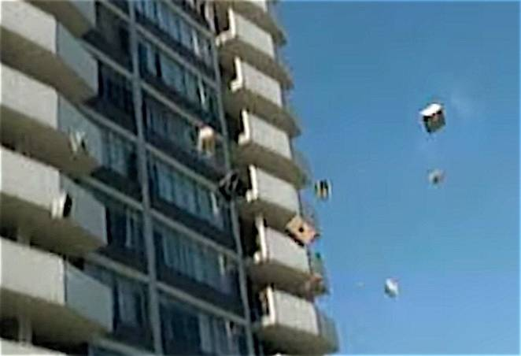

Special Collection of Furniture and Items
Please note all tenants and leaseholders are responsible for arranging special collection of bulky furniture and items through Brent Council.
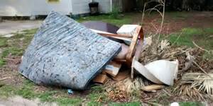
Kilburn Square Housing have incurred costs for refuse collection on the estate. This will have an impact on your service charges in the future if this continues to happen. To arrange a special collection contact Brent Council on 020 8937 5050.
When you are given your reference number you need to provide this to the staff at Kilburn Square reception along with a list of items and your collection date. All bulk refuse can then be placed at the side of the compound gates for collection.
Fire Safety
Following the recent fire at Grenfell Tower, naturally a number of residents will be concerned.
I can confirm that BHP have undertaken Fire Risk Assessment on the Tower block and we are 100% compliant.
Fire safety is the number one priority and BHP will continually review fire risk assessments, servicing and maintenance programmes to ensure residents are safe.
In order to ensure we maintain our safety, there are a number of things which you as residents can do to keep safe.

- Make sure you have a working smoke alarm in your home
- Keep balconies free from clutter
- Please don’t leave rubbish or bikes in communal areas or obstruct escape routes
- Make sure you know where your nearest fire exit is
- If you are a smoker please do not smoke in common arears of the block, including the lift.
- Always fully extinguish cigarettes smoked in your home and dispose of them carefully and safely.

MEETING TO DISCUSS FIRE SAFETY IN SOUTH KILBURN

Following the tragic fire at Grenfell Tower, a meeting has been organised for residents of South Kilburn to learn more about fire safety and to air any concerns or queries that you might have.

Tuesday 4 July
4-6pm with a drop-in session from 6-7pm
William Dunbar House Albert Road, London NW6 5DE
_________________________________

The meeting will be chaired by Tulip Siddiq, MP for Hampstead and Kilburn.

Representatives from the following organisations will also be in attendance:  • London Fire Brigade  • Brent Council  • Brent Housing Partnership  • L&Q Group  • Network Homes  Tea and coffee will be provided. |  | 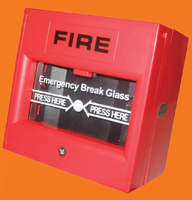

For more information on the council’s response to the Grenfell Tower fire, please go to: www.brent.gov.uk/grenfelltower

Tenants Responsibilities
As part of your Tenancy Agreement you have a number of responsibilities you must follow.
Your Tenancy Agreement sets out some rules that you, and those who live in or visit your home, must follow by law. Your full tenancy conditions and your rights and responsibilities are listed in your Tenancy Agreement, but here is a summary of the key points:
- Pay all charges for gas, electricity, and telephone services direct to your providers.
- Not to run a business from your home without our permission in writing or use your property for any criminal, illegal or immoral purposes;
- Not to cause a nuisance, annoyance or excessive noise, or allow your visitors to do so;
- Not to harass, threaten or use violence or intimidate people;
- Report promptly any repair or defect to KSHC;
- Allow workmen, employees or agents access at all reasonable hours to inspect the condition of the premises or to carry out repairs or other works to the premises or adjoining property. (KSHC will usually give at least 24 hours - notice but immediate access may be required in an emergency);
- Not to cause any damage to the premises or the fixtures and fittings belonging to Brent Council;
- Not to keep on the premises any mobile gas heaters, cylinders, oil burning appliances, paraffin or petrol;
- Keep all communal areas clean, tidy and free from obstructions and rubbish which might cause injury nuisance and annoyance to others;
- You must seek permission from KSHC to keep pets at your property, and ensure they do not cause a nuisance or foul in public or communal areas;
- Use the bin chutes and recycling bins properly.
Gas Safety Checks
Landlords are legally obliged (in accordance with Gas Safety Regulations 1998) to obtain a gas safety certificate (CP12) every twelve months. Therefore it is imperative that tenants co-operate with the Council in order for the (CP12) to be completed.
The contractor will be entitled to charge the Council for visits following evidence that they have arranged and made 3 unsuccessful visits. These charges will be recharged to the tenant.

Forced Entry
As a final mechanism to ensure the Council compliance with its statutory obligations, it will force entry to carry out a service. Every effort will be made to avoid this, through written correspondence and other appropriate methods of communication.
Please note if the Council have to apply to the courts for a warrant for forced entries. The tenant will be recharged £300.14 minimum, this could increase dependent on what locks are changed. The amount will be added to your rent account for recovery.
Security on the estate

Residents are reminded that they need to close the doors behind them when exiting their block.
Resident Participation
Come out in your numbers on a Friday in the committee room where there is fun and laughter and BINGO. It’s a way of meeting others on the estate and having fun. All are welcome.

Co-op Membership

All leaseholders and tenants are welcome to join Kilburn Square Housing Co-operative membership. Membership is £1.00 each. If you are a Co-op member you can attend General Meetings and Annual General Meetings and you can voice your opinions on matters. Have your say on the running of the estate and receive a discount price for events by Kilburn Square. Please note leaseholders sub-tenants cannot become a member.

Contact Information

We need to ensure that we have your current contact numbers on our database, particularly mobile numbers. If you have recently changed your contact number, please inform the office. We also need to be informed of your next of kin in case of emergencies.


Out of Hours Repairs
An emergency repairs service is available outside normal office hours.
To report a repair out of hours contact 0208 937 1234
Help with your Rent
Paying your rent and any charges should be your top priority, and regardless of how you pay, you are responsible for ensuring that these are paid in full, and on time. Non-payment of rent, service charges or any other charge could lead to you losing your home.
Tenants are reminded that rent is payable weekly in advance, or monthly in advance.

Housing staff will provide advice and guidance for tenants who have difficulty in paying rent. Whilst ‘Recovery of Possession’ (Eviction) of property is a last resort, Kilburn Square Housing Co-operative needs to protect its income and will take action against tenants who fail to pay their rent.
However, we recognise that there are many reasons why a tenant may have rent arrears.

If you have rent arrears and we have written to you, you must contact the Co-op office.

We will arrange a mutual appointment for you to see the Housing Officer or the Manager in confidence.

We will help you to get advice and support so that you can pay your rent.
And arrange a repayment plan to reduce and clear the arrears.

Housing Benefit
If you are on a low income or unemployed you may be entitled to claim Housing Benefit Rebate.
We can help you to do this.
Please remember your home is at risk if you do not pay your rent

Behaviour of Children on the estate

All parents must ensure that they take full responsibility for the behavior of their children and their friends. This includes when your child is playing on the estate. Parents and guardians must ensure that they know the whereabouts of their children and you should monitor your children when they are out to ensure they are safe.

Failing to ensure that members of household or visitors do not cause a nuisance is a breach of the terms and conditions of your agreement with Brent Council. Persistent anti- social behaviour may lead to agreements being terminated and the loss of your home.

Housing Management Staff structure 2017

Housing Services/Estate Manager Jennifer Williams

Housing Officer Linda Ponder

Finance Officer Yasmita Kotecha

Maintenance Officer Rudy Kelly

Front Desk/Security Co-ordinator Karis Pink

Caretakers William Borrill
Kathy Proudfoot Jones Ivory

MEETINGS AND EVENTS FOR 2017…………..

All Residents and Leaseholders are encouraged to attend future Board Meetings to have your say on how the TMO provide services to the estate.



Board Meetings are held every Month
11th July 2017
15th August 2017
12th September 2017
General & AGM meetings Thursdays
14th September 2017 AGM

