KILBURN SQUARE NEWSLETTER
  - September 2018

Useful information of what’s happening on your estate including events.
G




Welcome to Kilburn Square newsletter for September 2018.
Kilburn Square currently has 12 Committee Members;
please see below the names of our current Committee Members.
TITLE | NAME
Chair | Margaret Stoll
Deputy Chair | Vacant
Secretary | Jennifer Welch
Treasurer | Antonio Messina
Committee Member | James Lewis
Committee Member | Zaler Montana
Committee Member | Charlotte Foncecea
Committee Member | Maxwell Antwi
Committee Member  Committee Member  Committee Member  Committee Member  Committee Member | Patricia Hogan  Paul Keeley  Rehana Khawaja  Denise Prieto  Fatima Achach
Office Opening Hours- 9.00am- 5.00pm

Special Collection of Furniture and Items
Please note all tenants and leaseholders are responsible for arranging special collection of bulky furniture and items through Brent Council.
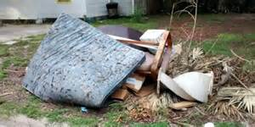
Kilburn Square Housing have incurred costs for refuse collection on the estate. This will have an impact on your service charges in the future if this continues to happen. To arrange a special collection contact Brent Council on 020 8937 5050.
When you are given your reference number you need to provide this to the staff at Kilburn Square reception along with a list of items and your collection date. All bulk refuse can then be placed at the side of the compound gates for collection.

Fire Safety



Following the recent fire at Grenfell Tower, naturally a number of residents will be concerned.
I can confirm that BHP have undertaken Fire Risk Assessment on the Tower block and we are 100% compliant.
Fire safety is the number one priority and BHP will continually review fire risk assessments, servicing and maintenance programmes to ensure residents are safe.
In order to ensure we maintain our safety, there are a number of things which you as residents can do to keep safe.

- Make sure you have a working smoke alarm in your home
- Keep balconies free from clutter
- Please don’t leave rubbish or bikes in communal areas or obstruct escape routes
- Make sure you know where your nearest fire exit is
- If you are a smoker please do not smoke in common arears of the block, including the lift.
- Always fully extinguish cigarettes smoked in your home and dispose of them carefully and safely.

Help with your Rent
Paying your rent and any charges should be your top priority, and regardless of how you pay, you are responsible for ensuring that these are paid in full, and on time. Non-payment of rent, service charges or any other charge could lead to you losing your home.
Tenants are reminded that rent is payable weekly in advance, or monthly in advance.

Housing staff will provide advice and guidance for tenants who have difficulty in paying rent. Whilst ‘Recovery of Possession’ (Eviction) of property is a last resort, Kilburn Square Housing Co-operative needs to protect its income and will take action against tenants who fail to pay their rent.
However, we recognise that there are many reasons why a tenant may have rent arrears.

If you have rent arrears and we have written to you, you must contact the Co-op office.

We will arrange a mutual appointment for you to see the Housing Officer or the Manager in confidence.

We will help you to get advice and support so that you can pay your rent.
And arrange a repayment plan to reduce and clear the arrears.

Housing Benefit
If you are on a low income or unemployed you may be entitled to claim Housing Benefit Rebate.
We can help you to do this.
Please remember your home is at risk if you do not pay your rent
Right To Buy
If you are a secure tenant and you have been a council or social housing tenant for three years or more, you may have the Right to Buy your council home. The three years can be built up over time using a number of tenancies and with gaps in between. If you have a Right to Buy application in progress only emergency repairs will be undertaken within your property.

Gas Safety Checks
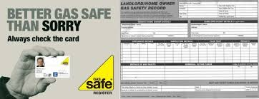
Landlords are legally obliged (in accordance with Gas Safety Regulations 1998) to obtain a gas safety certificate (CP12) every twelve months. Therefore it is imperative that tenants co-operate with the Council in order for the (CP12) to be completed.
The contractor will be entitled to charge the Council for visits following evidence that they have arranged and made 3 unsuccessful visits. These charges will be recharged to the tenant.

Forced Entry
As a final mechanism to ensure the Council compliance with its statutory obligations, it will force entry to carry out a service. Every effort will be made to avoid this, through written correspondence and other appropriate methods of communication.
Please note if the Council have to apply to the courts for a warrant for forced entries. The tenant will be recharged £300.14 minimum, this could increase dependent on what locks are changed. The amount will be added to your rent account for recovery.
Security on the estate

Residents are reminded that they need to close the doors behind them when exiting their block.
Resident Participation
Come out in your numbers on a Friday in the committee room where there is fun and laughter and BINGO. It’s a way of meeting others on the estate and having fun. All are welcome.

Co-op Membership

All leaseholders and tenants are welcome to join Kilburn Square Housing Co-operative membership. Membership is £1.00 each. If you are a Co-op member you can attend General Meetings and Annual General Meetings and you can voice your opinions on matters. Have your say on the running of the estate and receive a discount price for events by Kilburn Square. Please note leaseholders sub-tenants cannot become a member.
Permission to keep a pet
All residents are reminded you that you must seek written permission to keep a pet as detailed in your tenancy conditions.
Failure to seek consent may result in you having to re-home your pet immediately should your pet
Cause a nuisance or annoy other residents. You are responsible for your pet at all times, you must ensure that your dog is kept on a lead when on the estate and that you clean up any mess made by your dog.

Please note from April 2016 it now law that all dogs are microchipped and should wear a collar with a tag showing its’ owner’s name and address when out in public.

Brent Housing Partnership has produced a booklet on Animal Welfare Guidance if you have access to the intranet please go to the link below.

https://www.brent.gov.uk/media/9594812/Animal_Welfare_Guidance_Booklet.pdf

If you do not have access to the internet copies can be obtained from the Kilburn Square Office.

We are required to keep a register of all pets on the estate therefore please find enclosed a permission form to keep a pet which needs to be completed and returned to the office.

Before you buy a pet you need to obtain permission from Kilburn Square In advance.
Residents will not be given permission to keep a pet if it is considered by law to be dangerous or illegal in the United Kingdom.


Kilburn Square Tower Block
A number of residents have cats within the Tower block, please can you ensure that you wrap and discard all cat litter and faeces in secure bags.



Contact Information

We need to ensure that we have your current contact numbers on our database, particularly mobile numbers. If you have recently changed your contact number, please inform the office. We also need to be informed of your next of kin in case of emergencies.


Out of Hours Repairs
An emergency repairs service is available outside normal office hours.
To report a repair out of hours contact 0208 937 1234

Housing Management Staff structure 2018

Housing Services/Estate Manager Jennifer Williams

Housing Officer Linda Ponder

Finance Officer Yasmita Kotecha

Maintenance Officer Rudy Kelly

Front Desk/Security Co-ordinator Karis Pink

Caretakers William Borrill
Kathy Proudfoot Jones Ivory

MEETINGS AND EVENTS FOR 2018…………..

All Residents and Leaseholders are encouraged to attend future Board Meetings to have your say on how the TMO provide services to the estate.


Board Meetings are held every second Tuesday of the month
11th September 2018 – Annual General Meeting 13th September 2018
9th October 2018
13th November 2018
11th December 2018
13th December 2018- General Meeting and Christmas Party

Thursday 13th September 2018 -7.30pm in
the Committee Room
Don’t miss it!

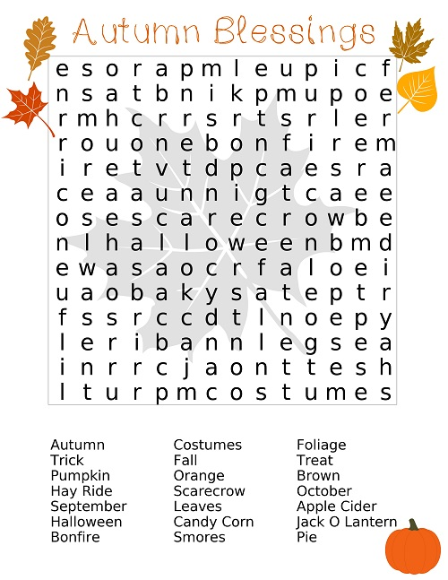

Repairs Tenants Responsibilities
- Internal Doors – Adapting doors to accommodate carpets, draught excluders, fittings and fixtures on internal doors, burglar alarms.

- Windows – Fittings and fixtures

- Lost keys, Locks and Fobs- Replacing locks, keys and fobs.

- Kitchen Unit Doors- Hanging off/hinges broken, handle on cupboard broken.

- Skirting Boards, Fixing minor gaps between skirting boards and doors.

- Curtain Rails- Installation

- Any internal glazing

- Electrical Fittings – broken by tenant

- Damaged Socket Outlet Plate

- Plugs and chains

- Blockages to WC- Caused by tenant neglect

- WC toilet pan, wash hand basin, bath- if broken by tenant

- Toilet seat

- Wall tiles- Splash back to sink, bath or basin

- Floor tiles

- Garage Doors- Keys lost

- Plumbing in washing machines and dishwashers

- Fitting TV aerial/satellite dishes (subject to Co/op approval).

- Smart Meter installation (Co-op office must be informed in advance)

- All repairs must be reported to the office and not directly to the maintenance man or caretakers.

- Do not put large items down the rubbish chutes.

- Installation of laminated flooring needs to be approved by the Co-op.
Any other items vandalised or broken by tenants or your visitor’s misuse. The Co-op will make safe but you will be re-charged and the amount added to your rent account.

