KILBURN SQUARE NEWSLETTER
  - March 2018

Useful information of what’s happening on your estate including events.
G




Welcome to Kilburn Square newsletter for March 2018.
Kilburn Square Board Members
TITLE | NAME
Chair | Margaret Stoll
Deputy Treasurer | Patricia Hogan
Secretary  Deputy Secretary | Jennifer Welch  Pauline Fell
Treasurer | Antonio Messina
Committee Member | Charlotte Fonceca
Committee Member | Maxwell Antwi
Office Opening Hours- 9.00am- 5.00pm

Special Collection of Furniture and Items
Please note all tenants and leaseholders are responsible for arranging special collection of bulky furniture and items through Brent Council.

Kilburn Square Housing have incurred costs for refuse collection on the estate. This will have an impact on your service charges in the future if this continues to happen. To arrange a special collection contact Brent Council on 020 8937 5050.
When you are given your reference number you need to provide this to the staff at Kilburn Square reception along with a list of items and your collection date. All bulk refuse can then be placed at the side of the compound gates for collection.

Fire Safety



Following the recent fire at Grenfell Tower, naturally a number of residents will be concerned.
I can confirm that BHP have undertaken Fire Risk Assessment on the Tower block and we are 100% compliant.
Fire safety is the number one priority and BHP will continually review fire risk assessments, servicing and maintenance programmes to ensure residents are safe.
In order to ensure we maintain our safety, there are a number of things which you as residents can do to keep safe.

- Make sure you have a working smoke alarm in your home
- Keep balconies free from clutter
- Please don’t leave rubbish or bikes in communal areas or obstruct escape routes
- Make sure you know where your nearest fire exit is
- If you are a smoker please do not smoke in common arears of the block, including the lift.
- Always fully extinguish cigarettes smoked in your home and dispose of them carefully and safely.

Right To Buy
If you are a secure tenant and you have been a council or social housing tenant for three years or more, you may have the Right to Buy your council home. The three years can be built up over time using a number of tenancies and with gaps in between. If you have a Right to Buy application in progress only emergency repairs will be undertaken within your property.

Kilburn Square Parking Charges as from 1st April 2018

Kilburn Square parking charges will remain the same details as follows:
- Each registered address on the estate may apply for up to 1 resident permit.
- Permits will not be issued to non- leaseholders or sub tenants.
- Resident permits will cost £30.00 each and will be valid for 1 year
Visitor permits will be single use scratch cards which are supplied in books of 12 costing £20.00
BLUE BADGE HOLDERS
- Blue badge holders are NOT exempt from the scheme and still need to apply for a permit which they must display along with their blue badge.
- Blue badge holders are entitled to one free permit per blue badge.
- It is the responsibility of the driver to clearly display the blue badge and permit so that all details are readable otherwise the vehicle will be liable to be issued a PCN
Where marked disabled bays exist, blue badge users should use those bays whenever possible to ensure other bays are kept free for other users who are not entitled to park in the disabled bays
Renewing a permit
- Permits will not automatically be renewed
- It is the responsibility of the resident to renew a resident permit.
- Upon renewal, if no details have changed, you will not need to resubmit proof of vehicle ownership or of address. However in this instance, the application must be made in the same name and address as previous, and the "renewal" box must be checked on the application form
If you have moved you will need to complete a new application for the new address where the vehicle is registered to
Permit Applications
- Permit applications can be made:
- by Post
- by Email or
- online
- Permit Application Forms are available:
- Enclosed in this booklet
- Downloadable from our website, www.wingparking.co.uk
Full details of how to apply are contained on the Permit Application Form

A copy of the full detailed car parking scheme and regulations can be obtained from the Kilburn Square Office.

Feedback from Survey carried out in 2017
Brent Council commissioned Newman Francis Ltd to carry out a survey to obtain the views of the residents on the estate, and to look at ways they could help assist the TMO in delivering an effective service.


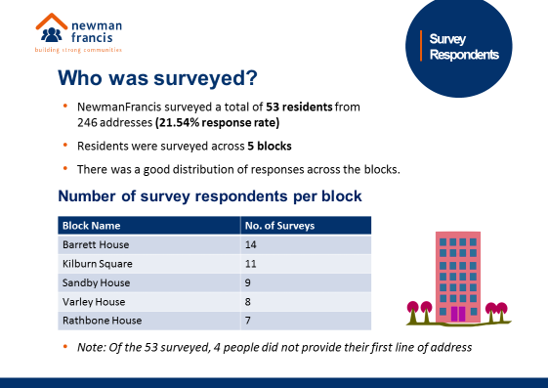

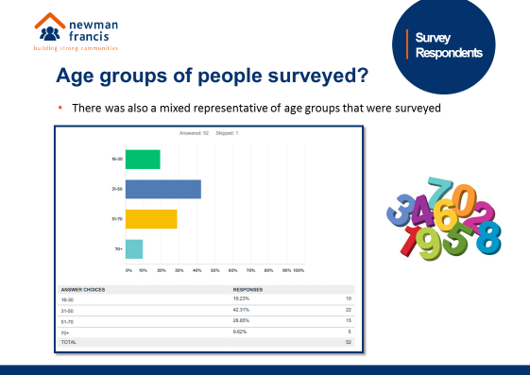

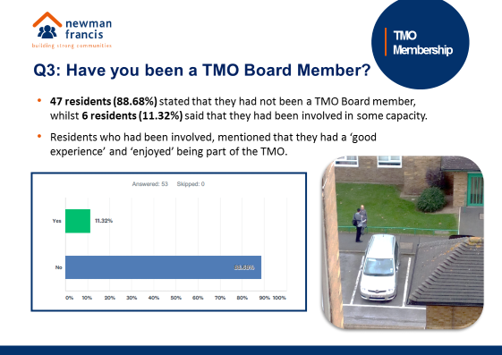

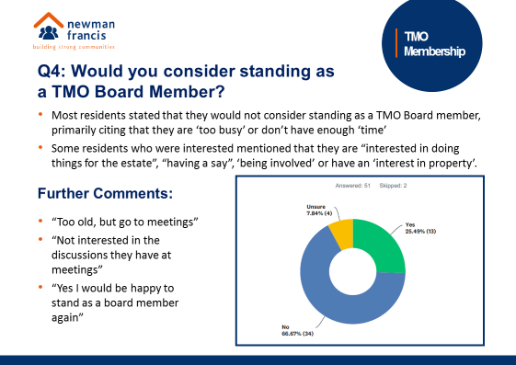

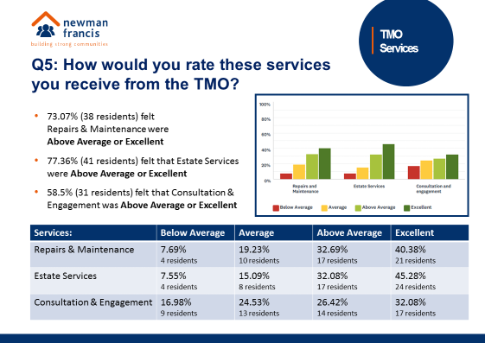

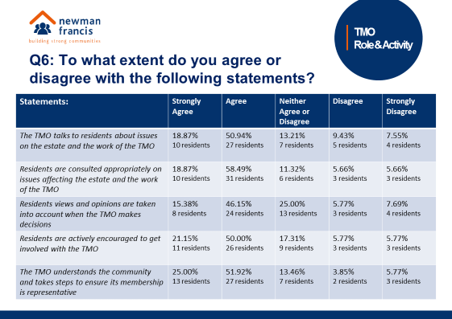

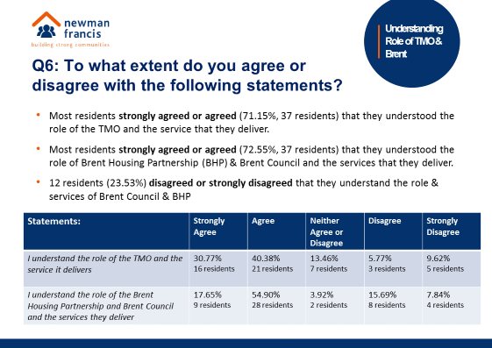

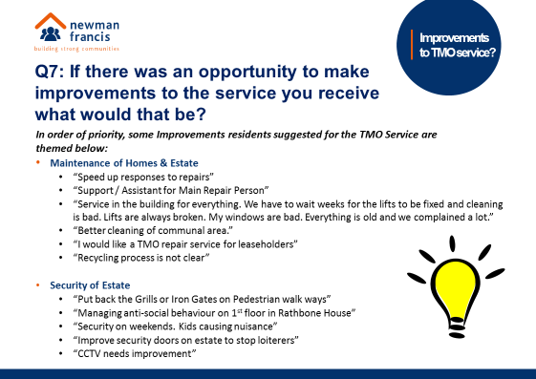

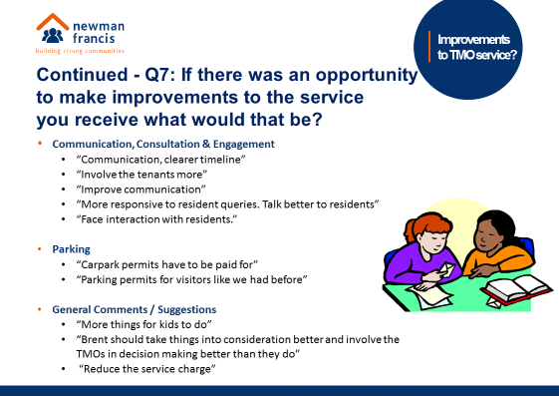
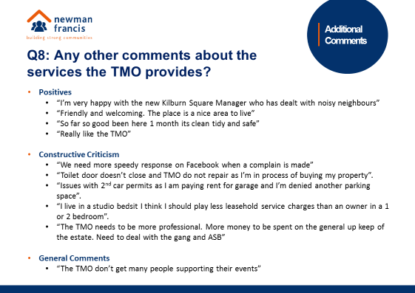

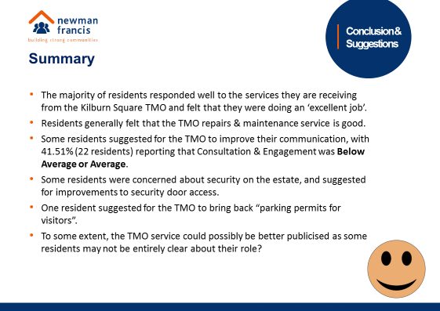

A copy of the survey is available from the Kilburn Square office.

Help with your Rent
Paying your rent and any charges should be your top priority, and regardless of how you pay, you are responsible for ensuring that these are paid in full, and on time. Non-payment of rent, service charges or any other charge could lead to you losing your home.
Tenants are reminded that rent is payable weekly in advance, or monthly in advance.

Housing staff will provide advice and guidance for tenants who have difficulty in paying rent. Whilst ‘Recovery of Possession’ (Eviction) of property is a last resort, Kilburn Square Housing Co-operative needs to protect its income and will take action against tenants who fail to pay their rent.
However, we recognise that there are many reasons why a tenant may have rent arrears.

If you have rent arrears and we have written to you, you must contact the Co-op office.

We will arrange a mutual appointment for you to see the Housing Officer or the Manager in confidence.

We will help you to get advice and support so that you can pay your rent.
And arrange a repayment plan to reduce and clear the arrears.

Housing Benefit
If you are on a low income or unemployed you may be entitled to claim Housing Benefit Rebate.
We can help you to do this.
Please remember your home is at risk if you do not pay your rent

Gas Safety Checks

Landlords are legally obliged (in accordance with Gas Safety Regulations 1998) to obtain a gas safety certificate (CP12) every twelve months. Therefore it is imperative that tenants co-operate with the Council in order for the (CP12) to be completed.
The contractor will be entitled to charge the Council for visits following evidence that they have arranged and made 3 unsuccessful visits. These charges will be recharged to the tenant.

Forced Entry
As a final mechanism to ensure the Council compliance with its statutory obligations, it will force entry to carry out a service. Every effort will be made to avoid this, through written correspondence and other appropriate methods of communication.
Please note if the Council have to apply to the courts for a warrant for forced entries. The tenant will be recharged £300.14 minimum, this could increase dependent on what locks are changed. The amount will be added to your rent account for recovery.
Security on the estate

Residents are reminded that they need to close the doors behind them when exiting their block.
Resident Participation
Come out in your numbers on a Friday in the committee room where there is fun and laughter and BINGO. It’s a way of meeting others on the estate and having fun. All are welcome.

Co-op Membership

All leaseholders and tenants are welcome to join Kilburn Square Housing Co-operative membership. Membership is £1.00 each. If you are a Co-op member you can attend General Meetings and Annual General Meetings and you can voice your opinions on matters. Have your say on the running of the estate and receive a discount price for events by Kilburn Square. Please note leaseholders sub-tenants cannot become a member.
Leaseholder Information Renting out your home/subletting


All leaseholders are reminded that they need to contact Brent Council to request a ‘Notice of Sublet’ application form which provides general advice for subletting leaseholders. There is a one off payment off £60.00 (including VAT). You need to ensure that when letting your property you provide Brent in writing the contact information of the people managing your property (letting agents etc).

Please note if you do not inform the Council you are subletting you are in breach of your lease and they can take legal action.
If you plan to rent out your flat then please make sure you in form the Council and the TMO estate office four weeks before your tenant moves in.

Many leaseholders want to make home improvements to their properties which may include structural work and alterations. However, some work may require you to get written permission (as a condition of your lease) from the council before you proceed.

Examples of work that needs permission:
- Replacing windows to your property
- Redecorating the outside of your property
- Building an extension
- Removing walls or a chimney breast
- Disconnecting shared heating
- Converting a loft.
When you have the council’s permission, you must still keep to any planning and building regulations, the current standards of the gas, water and electricity companies, any conditions attached to the permission itself. For more information and to request a form please email: housingmanagement@brent.go.uk

What Leaseholders should know about anti-social behaviour

The Council expects leaseholders to use their home in a responsible way and treat their neighbours with respect. However, the council will take action against those who cause nuisance. If you are renting out your property please ensure that any tenancy agreement with your tenant insists they and their visitors behave in a way that does not cause a nuisance to other residents.
If your tenant creates a nuisance, it is your responsibility to take action to stop them from doing so. If you don’t, the Council may take legal action against you.

Contact Information

We need to ensure that we have your current contact numbers on our database, particularly mobile numbers. If you have recently changed your contact number, please inform the office. We also need to be informed of your next of kin in case of emergencies.

Out of Hours Repairs
An emergency repairs service is available outside normal office hours.
To report a repair out of hours contact 0208 937 1234

Housing Management Staff structure 2018

Housing Services/Estate Manager Jennifer Williams

Housing Officer Linda Ponder

Finance Officer Yasmita Kotecha

Maintenance Officer Rudy Kelly

Front Desk/Security Co-ordinator Karis Pink

Caretakers William Borrill
Kathy Proudfoot Jones Ivory
MEETINGS AND EVENTS FOR 2018…………..

All Residents and Leaseholders are encouraged to attend future Board Meetings to have your say on how the TMO provide services to the estate.


Board Meetings  Tuesdays at 7.00pm | General and Annual General Meetings  Thursday at 7.30pm
13th March 2018 | General Meeting  15th March 2018
10th April 2018
15th May 2018
12th June 2018 | General Meeting  14th June 2018
10th July 2018
14th August 2018
11th September 2018 | Annual General Meeting  13th September 2018
9th October 2018
13th November 2018
11th December 2018 | General Meeting and Christmas Party  13th December 2018
